C L A S S E S I N R O G E R S T O N E

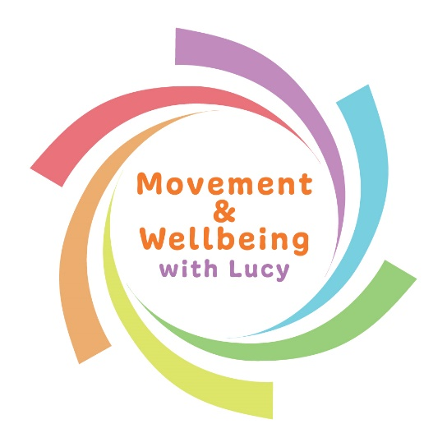
M O N D A Y M O R N I N G S
A T
Tydu Community Hall, Welfare grounds, Newport, NP10 9EQ

P I L A T E S
9.30 – 10.15am

MUMMY & BABY YOGA
*Booking is essential – block payment & PAYG options*
10.30 – 11.20am

*Please don’t hesitate to contact me to ask any questions*
Contact Lucy Cummings:
07510 055 928
Lucy.phillips91@hotmail.co.uk
Facebook: Yoga with Lucy / @Movement & Wellbeing with Lucy

