


01873 857 211

enquiries@alungriffiths.co.uk www.alungriffiths.co.uk

Waterways House, Merthyr Road, Llanfoist, Abergavenny, Monmouthshire, NP7 9PE

10/08/2026
Advance notice of planned works

Dear Neighbour

We are writing to update you that the Griffiths Project Team will be carrying the following construction works on behalf of Jubilee Park Management.

- Continuation of re-cutting the swale (open drainage ditch) from Jubilee Park Primary School to approximately 600m past the primary school, adjacent to River Reach (phase 2 & 3).

- Riverbank repair enabling works.

- Riverbank repair main works and reinstatement of Public Right of Way footpath from Jubilee Park to the Welfare Grounds.

The works are planned as follows:

Re-cutting of the swale

Phase 2 & 3 works are scheduled to commence on Tuesday, 11th August 2026, lasting approximately 2 weeks. To facilitate the safe removal of arisings from the swale, a temporary closure of the footpath adjacent to the school and leading to Jubilee Park Playground will be required (refer to Figure 1)

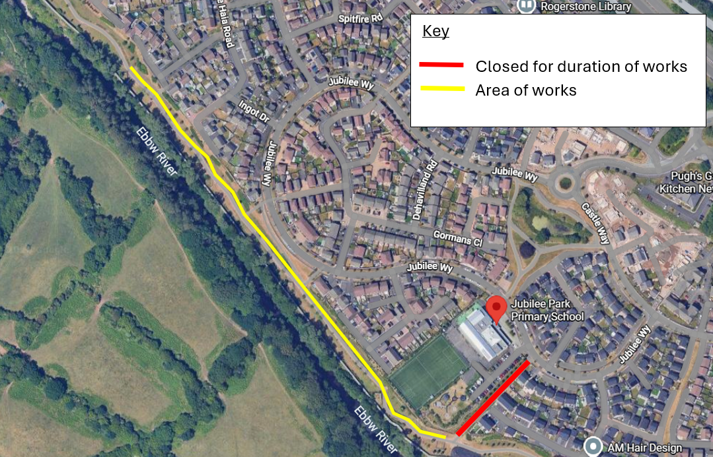
Figure 1 – Area close to enable Swale Works

Riverbank repair enabling works

Riverbank repair enabling works are scheduled to commence on Friday 14th August 2026 lasting approximately 1 week. Enabling works consist of constructing a temporary crane platform, installation of temporary boundary fencing and installation of construction welfare facilities in advance to the main construction works commencing. Please refer to Figure 2 for detail of the enabling works location.

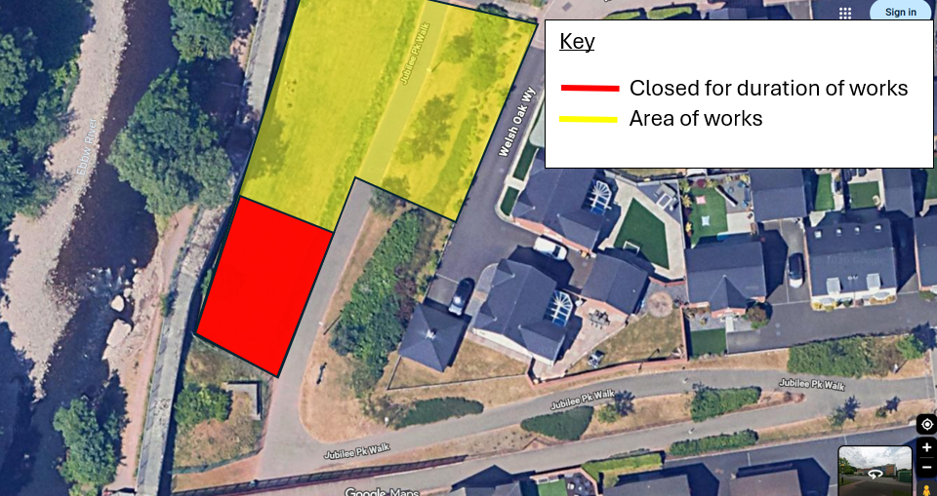
Figure 2 – Area close to enable Riverbank repair enabling works

Riverbank repair Main works

works are scheduled to commence on Monday, 24th August 2026 lasting approximately 11 weeks. To facilitate the safe undertaking of the works, a temporary footpath closure of a section of Jubilee Park Walk will be required for the duration of the works to provide safe access and egress of construction equipment and materials along with a working compound (refer to Figure 3). Pedestrian access along the footpath from Park Way over the Ebbw River footbridge will be maintained throughout the works.

Due to the nature of the works, a significant volume of materials will need to be delivered to the working area. The primary delivery route will be via Jubilee Way, Park Way, and a short section of the Jubilee Park Walk footpath. All deliveries will be scheduled and controlled by Griffiths site supervision to ensure safe and efficient access to the site.

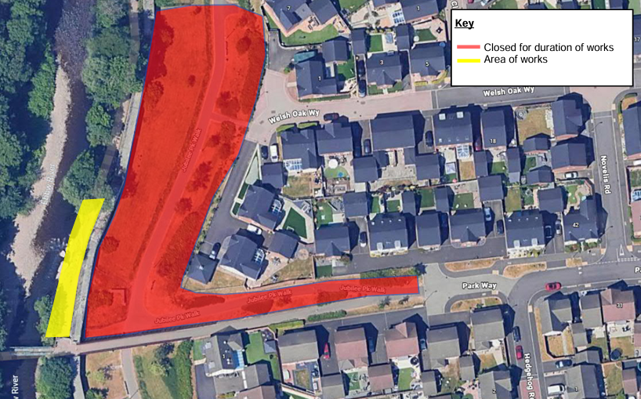
Figure 3 – Area close to enable Riverbank Works

Works will generally be undertaken between 08:00 to 18:00hrs. Please note that these dates are subject to change should any unforeseen circumstances arise.

We apologise for any inconvenience this may cause however, the closures are necessary to ensure the works are carried out safely and efficiently.

Should you have any queries in relation to these works, please don’t hesitate to contact us on 01873 771782 (please note this number is only monitored Monday-Friday, between 8.30am and 5pm).

Kind regards,

Griffiths Project Team

