


01873 857 211

enquiries@alungriffiths.co.uk www.alungriffiths.co.uk

Waterways House, Merthyr Road, Llanfoist, Abergavenny, Monmouthshire, NP7 9PE

17/09/2026
Update to planned works in your area

Dear Neighbour

We are writing to update you on the planned works that the Griffiths Project Team have been and are continuing to carry out on behalf of Jubilee Park Management.

- Instructed swale drainage works are now complete.

- Riverbank repair enabling works are now complete.

- Riverbank repair main works and reinstatement of Public Right of Way footpath from Jubilee Park to the Welfare Grounds – continuing. Please see below update.

Riverbank Repair - Main works

Works commenced on Monday, 24th August 2026 and will last approximately 11 weeks. To facilitate the safe undertaking of the works, the planned temporary footpath closure of a section of Jubilee Park Walk has been successfully implemented in line with Figure 3 below.

Due to the nature of the works, a significant volume of materials will need to be delivered to the working area. Some of the deliveries have already taken place, all of which have been undertaken successfully. The primary delivery route is via Jubilee Way, Park Way, and a short section of the Jubilee Park Walk footpath. All deliveries are scheduled and controlled by Griffiths site supervision to ensure safe and efficient access to the site. We would like to thank you for your cooperation and kindly ask residents to continue respecting the blue and white cones placed to restrict parking in certain areas of Park Way and Novelis Road. These restrictions are essential to maintaining the safe and efficient movement of deliveries.

To facilitate the riverbank works, a temporary river dam will be installed to provide safe access for personnel and plant undertaking activities within the channel. To maintain a dry working area, a water-management pumping system will be used to over-pump any seepage entering the works area. The system is controlled by a float switch, activating automatically when the trigger level is reached, meaning pumping will operate intermittently on a 24-hour basis.

Engagement with the Local Authority was completed in advance of the works commencing to agree the proposed methodology and associated noise-mitigation measures. In accordance with the Control of Pollution Act 1974, Section 61, prior consent was been granted for these works (Ref: 26/08686/ABN61F).

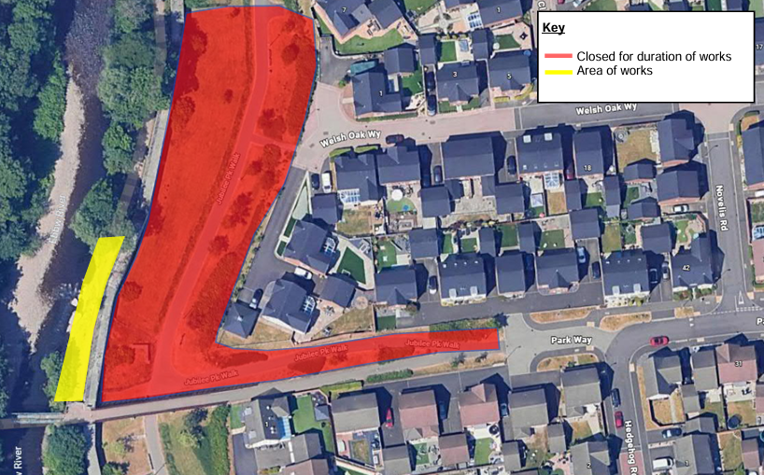
Figure 3 – Area close to enable Riverbank Works

Works will generally be undertaken between 08:00 to 18:00hrs. Please note that these dates are subject to change should any unforeseen circumstances arise.

We appreciate that these works may cause temporary inconvenience and would like to assure you that the team is doing its utmost to minimise any disturbance. We would like to thank you again for your patience and support to date.

Please note the amendment to our contact number, should you have any queries in relation to these works. Please don’t hesitate to contact us on 01873 857 211 (please note this number is only monitored Monday-Friday, between 8.30am and 5pm).

Kind regards,

Griffiths Project Team

